CTECH 22043

OBJECT ORIENTED

PROGRAMMING

Srirajitha.S

CT/2021/047

LW_02

Q1

a.

package Q1;  
  
public class Q1 {  
 public static void main(String[] args) {  
  
 int A = 10;  
 int B = 20;  
 int C = 30;  
  
 double result = Math.*pow*(B,2) + 4 * A * C;  
  
 System.*out*.println("the answer is :"+result);  
  
  
 }  
  
}

Output

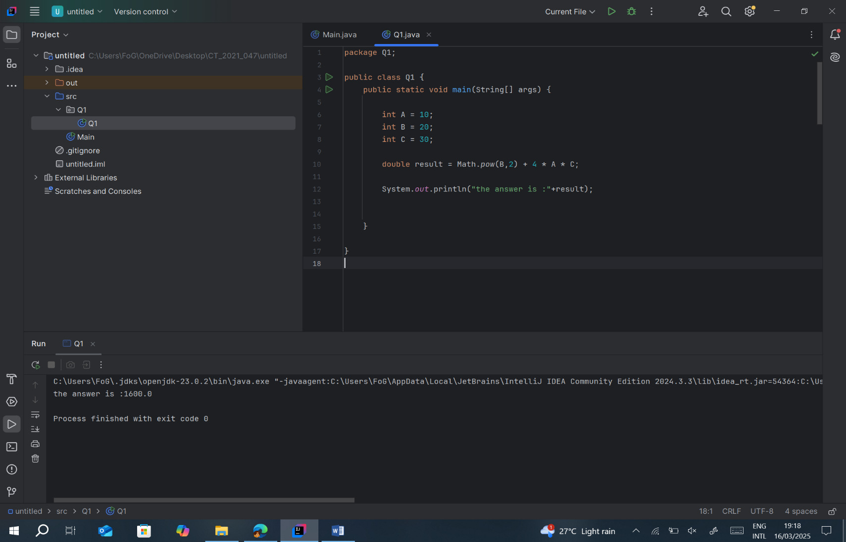

b , c, d

package Q1;  
  
public class Q2 {

// question b  
 public static void main(String[] args) {  
 int X = 10;  
 int Y = 15;  
 double result = Math.*sqrt*(X + 4 * Math.*pow*(Y, 3));  
 System.*out*.println("the answer is "+result);  
// question c  
 double result1 = Math.*cbrt*(X * Y);  
 System.*out*.println("the result is "+result1);  
  
// question d  
 int radius = 7;  
 double area = Math.*PI* * Math.*pow*(radius, 2);  
 System.*out*.println("the area of a circle is "+area);  
   
  
  
 }  
}

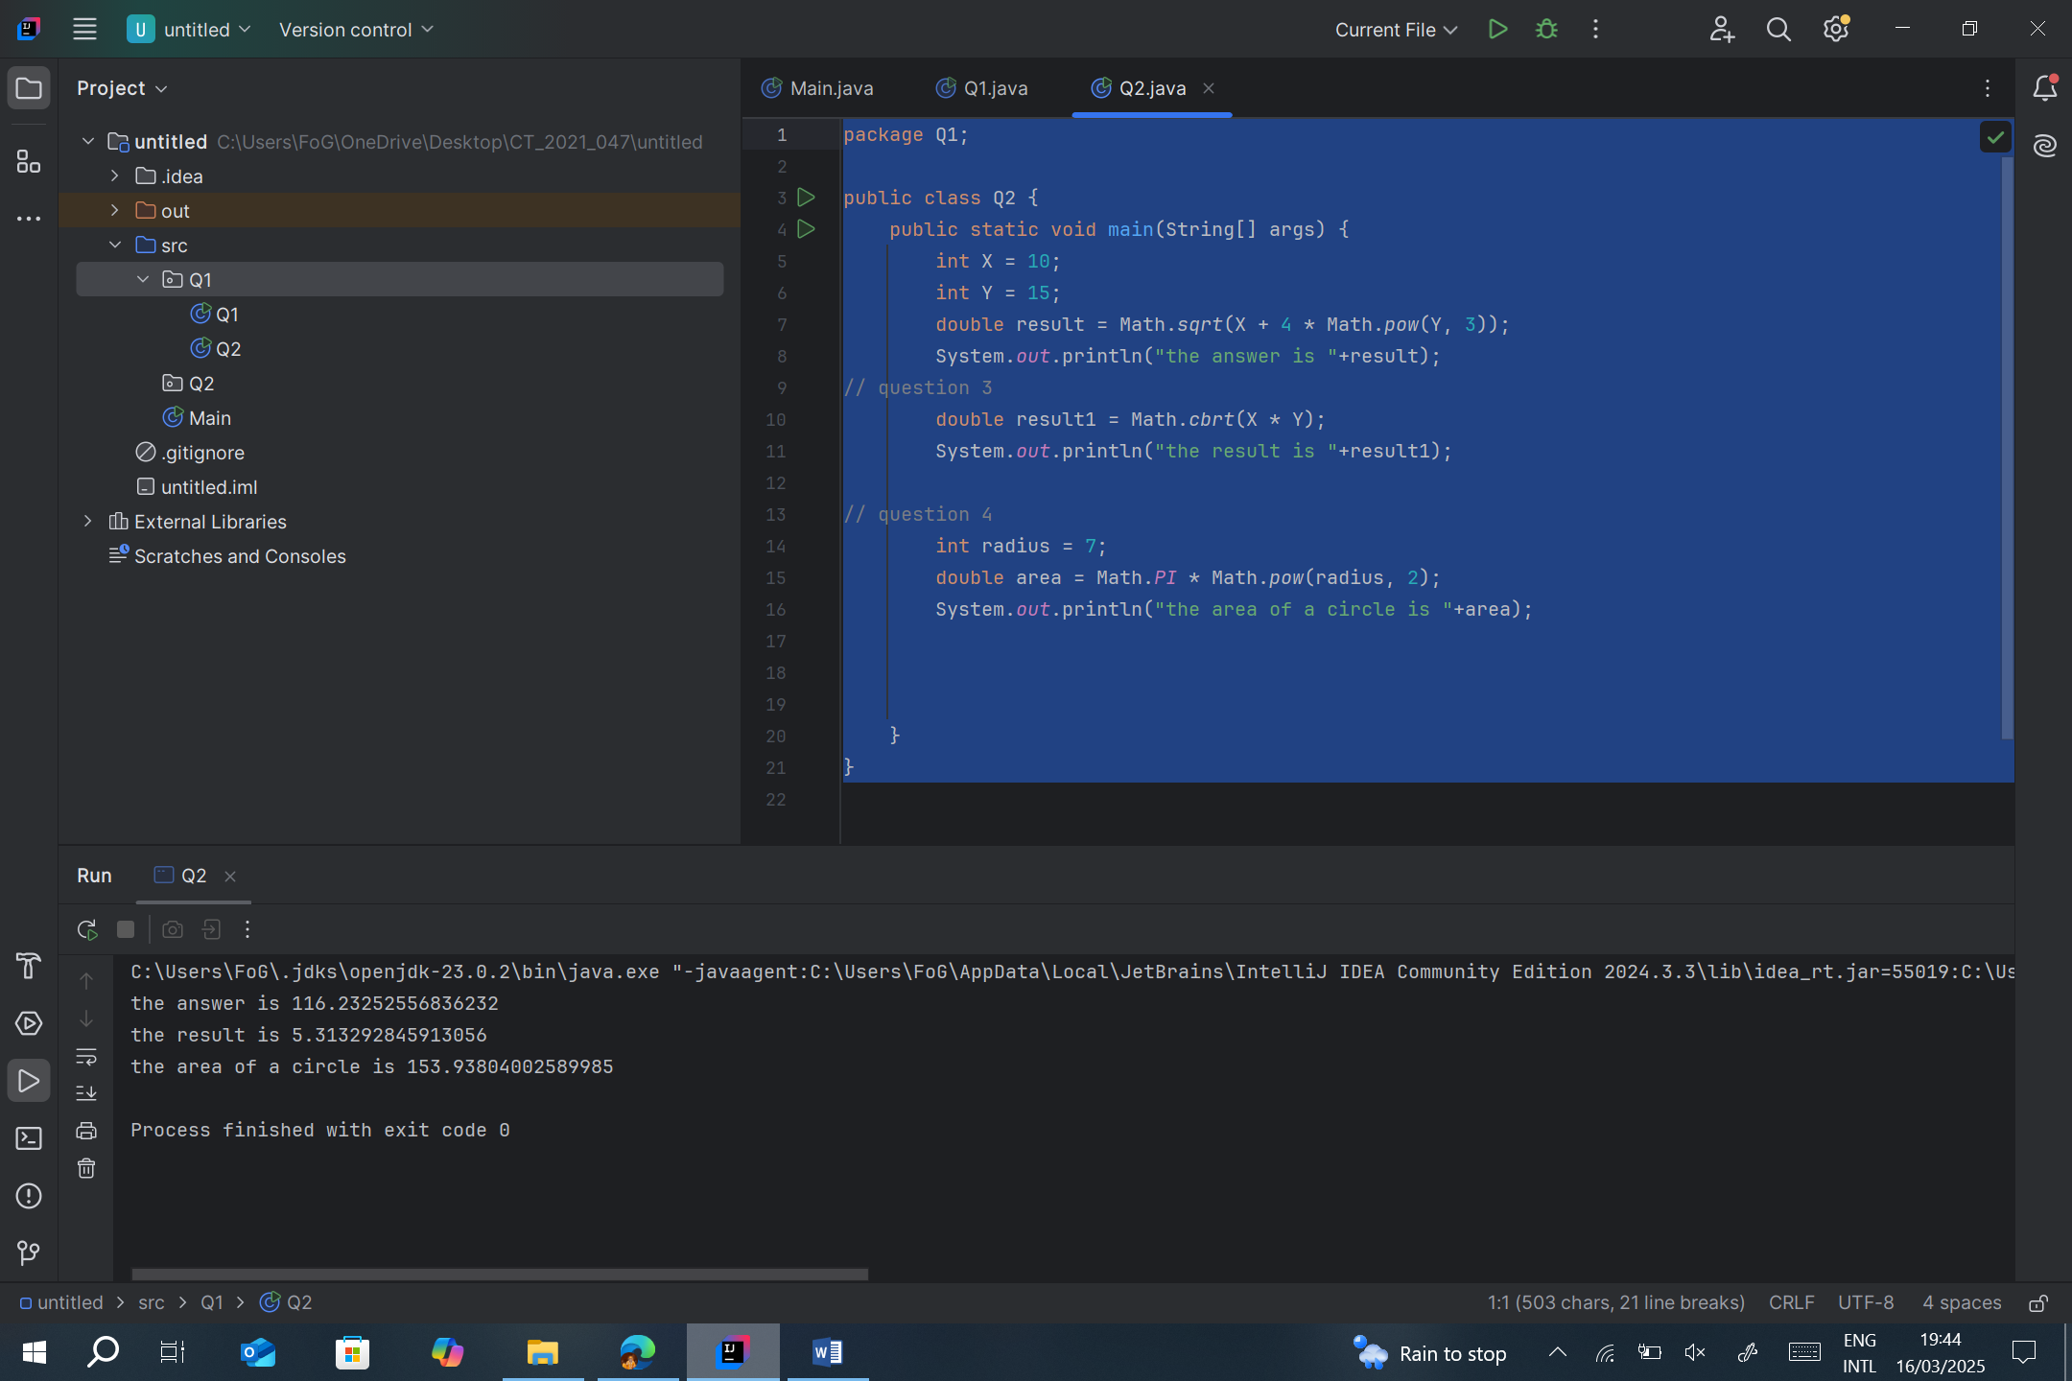

Q2.

}package Q2;  
import java.util.Scanner;  
public class Q_2 {  
 public static void main(String[] args) {  
 Scanner scanner = new Scanner(System.*in*);  
 System.*out*.print("Enter length in centimeters: ");  
 double cm = scanner.nextDouble();  
  
 double inches = cm / 2.54;  
 int feet = (int) (inches / 12);  
 inches = inches % 12;  
 System.*out*.printf("%d feet and %.2f inches\n", feet, inches);  
 }  
}

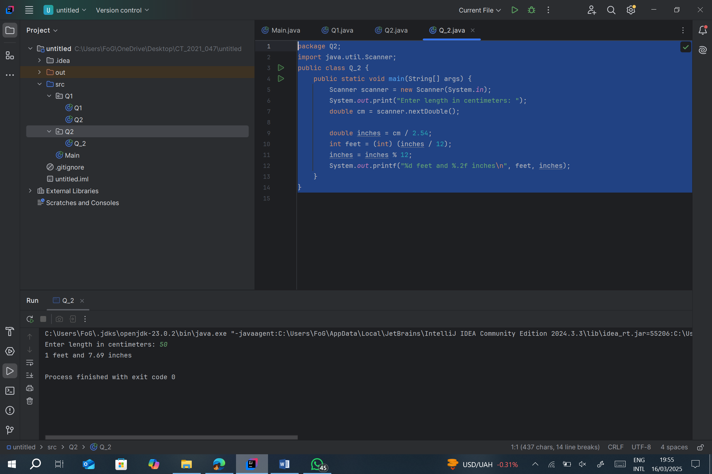

Q3.

package Q3;  
import java.util.Scanner;  
  
public class Q_3{  
 public static void main(String[] args) {  
 Scanner scanner = new Scanner(System.*in*);  
 System.*out*.print("Enter temperature in Celsius: ");  
 double celsius = scanner.nextDouble();  
  
 double fahrenheit = (1.8 * celsius) + 32;  
 System.*out*.printf("Temperature in Fahrenheit: %.2f\n", fahrenheit);  
 }  
}

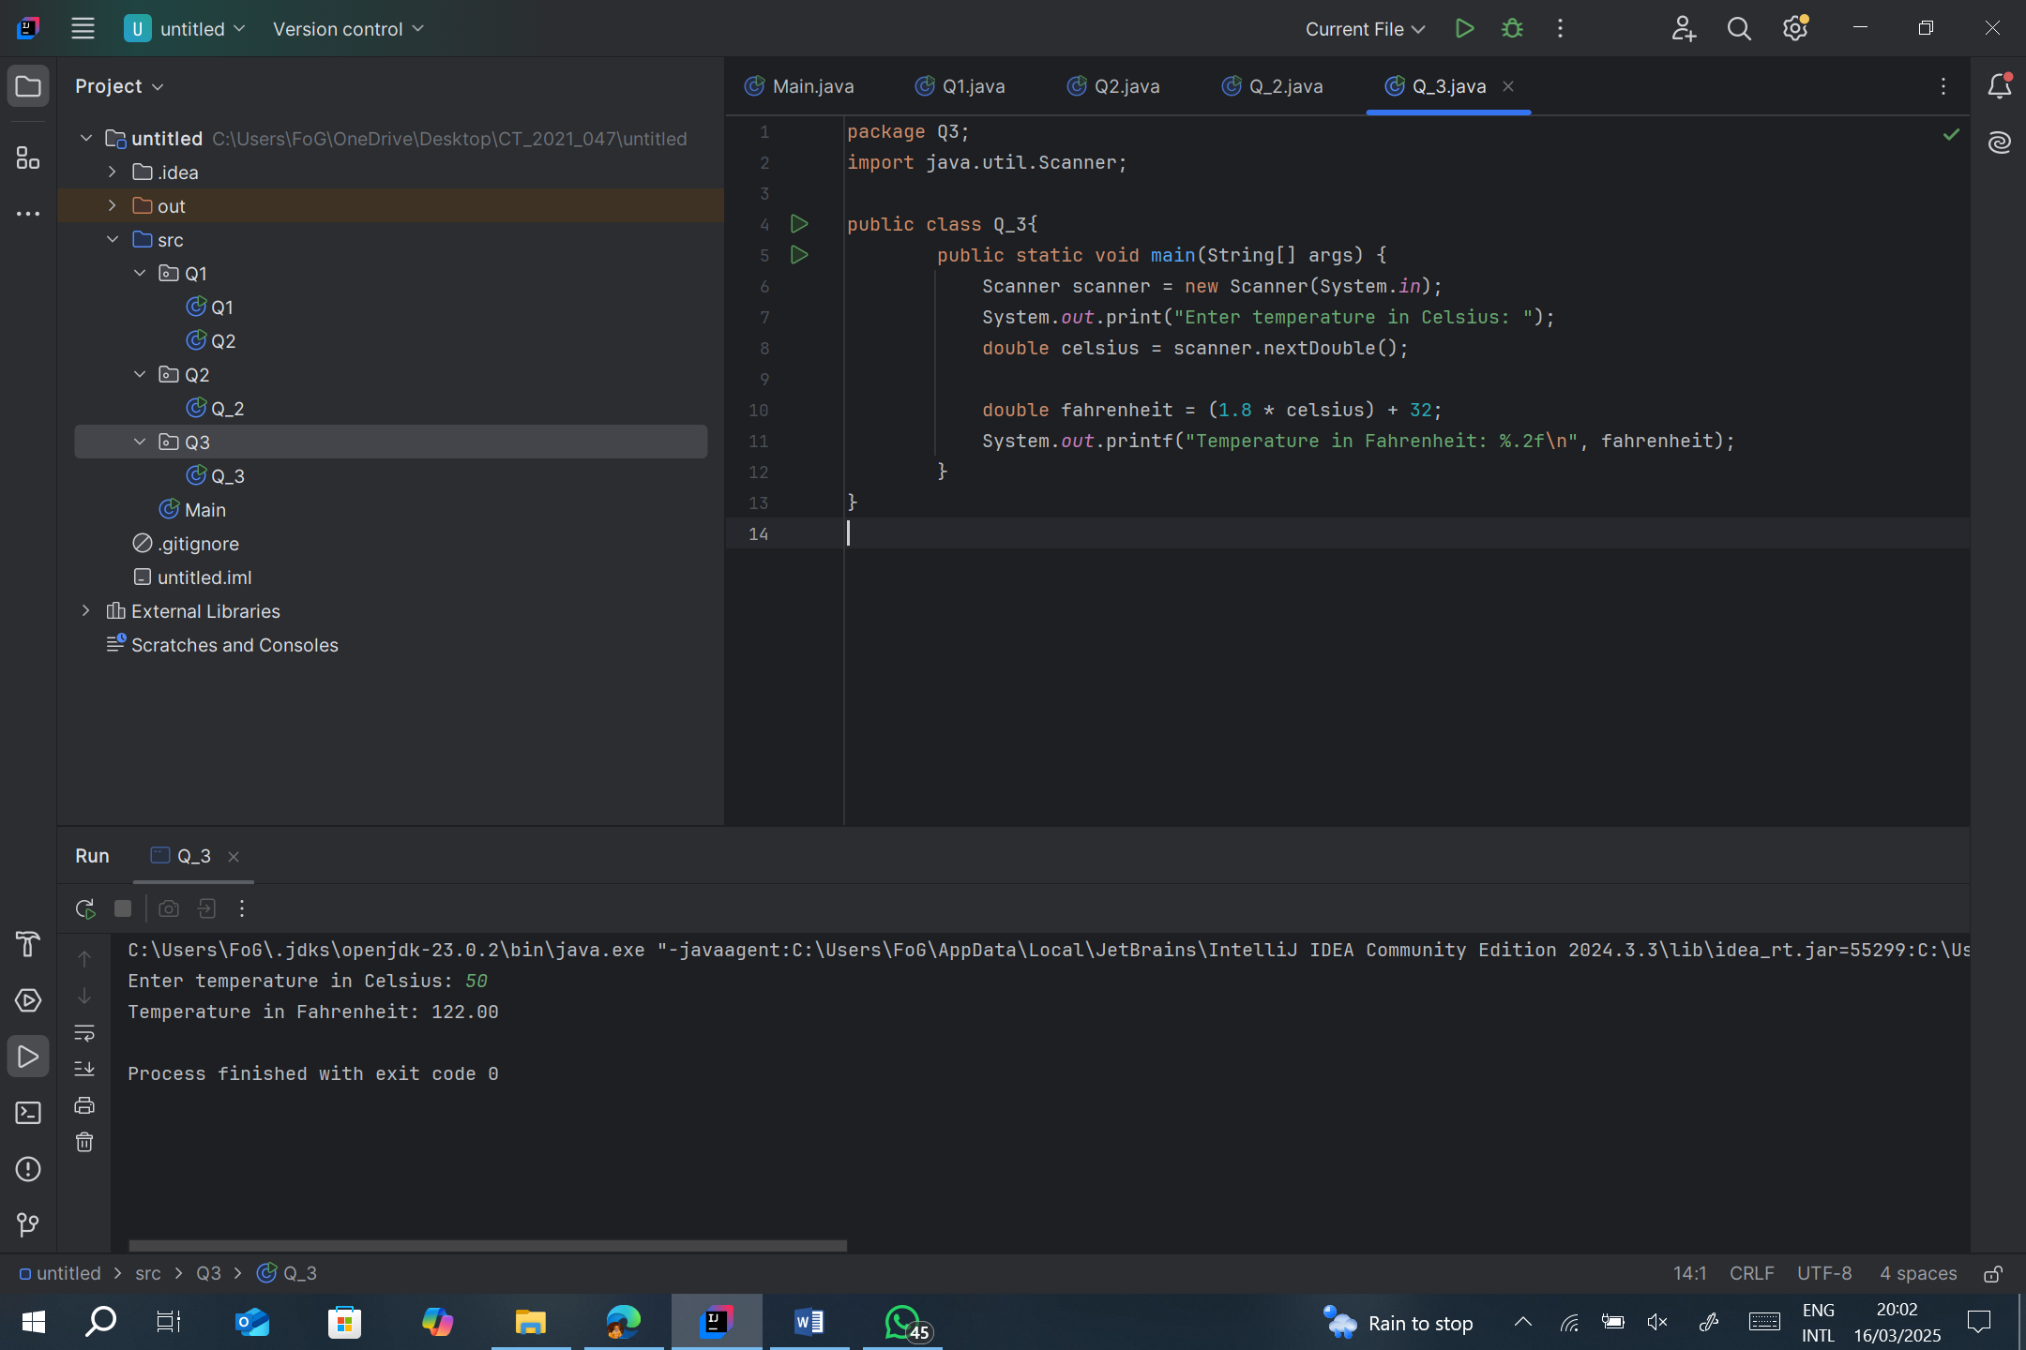

Q4.

package Q4;  
  
import java.util.Scanner;  
  
public class Q_4 {  
 public static void main(String[] args) {  
 Scanner scanner = new Scanner(System.*in*);  
 System.*out*.print("Enter your weight in pounds: ");  
 double bodyWeight = scanner.nextDouble();  
  
 double calories = bodyWeight * 19;  
 System.*out*.printf("You need %.2f calories per day.\n", calories);  
 }  
}

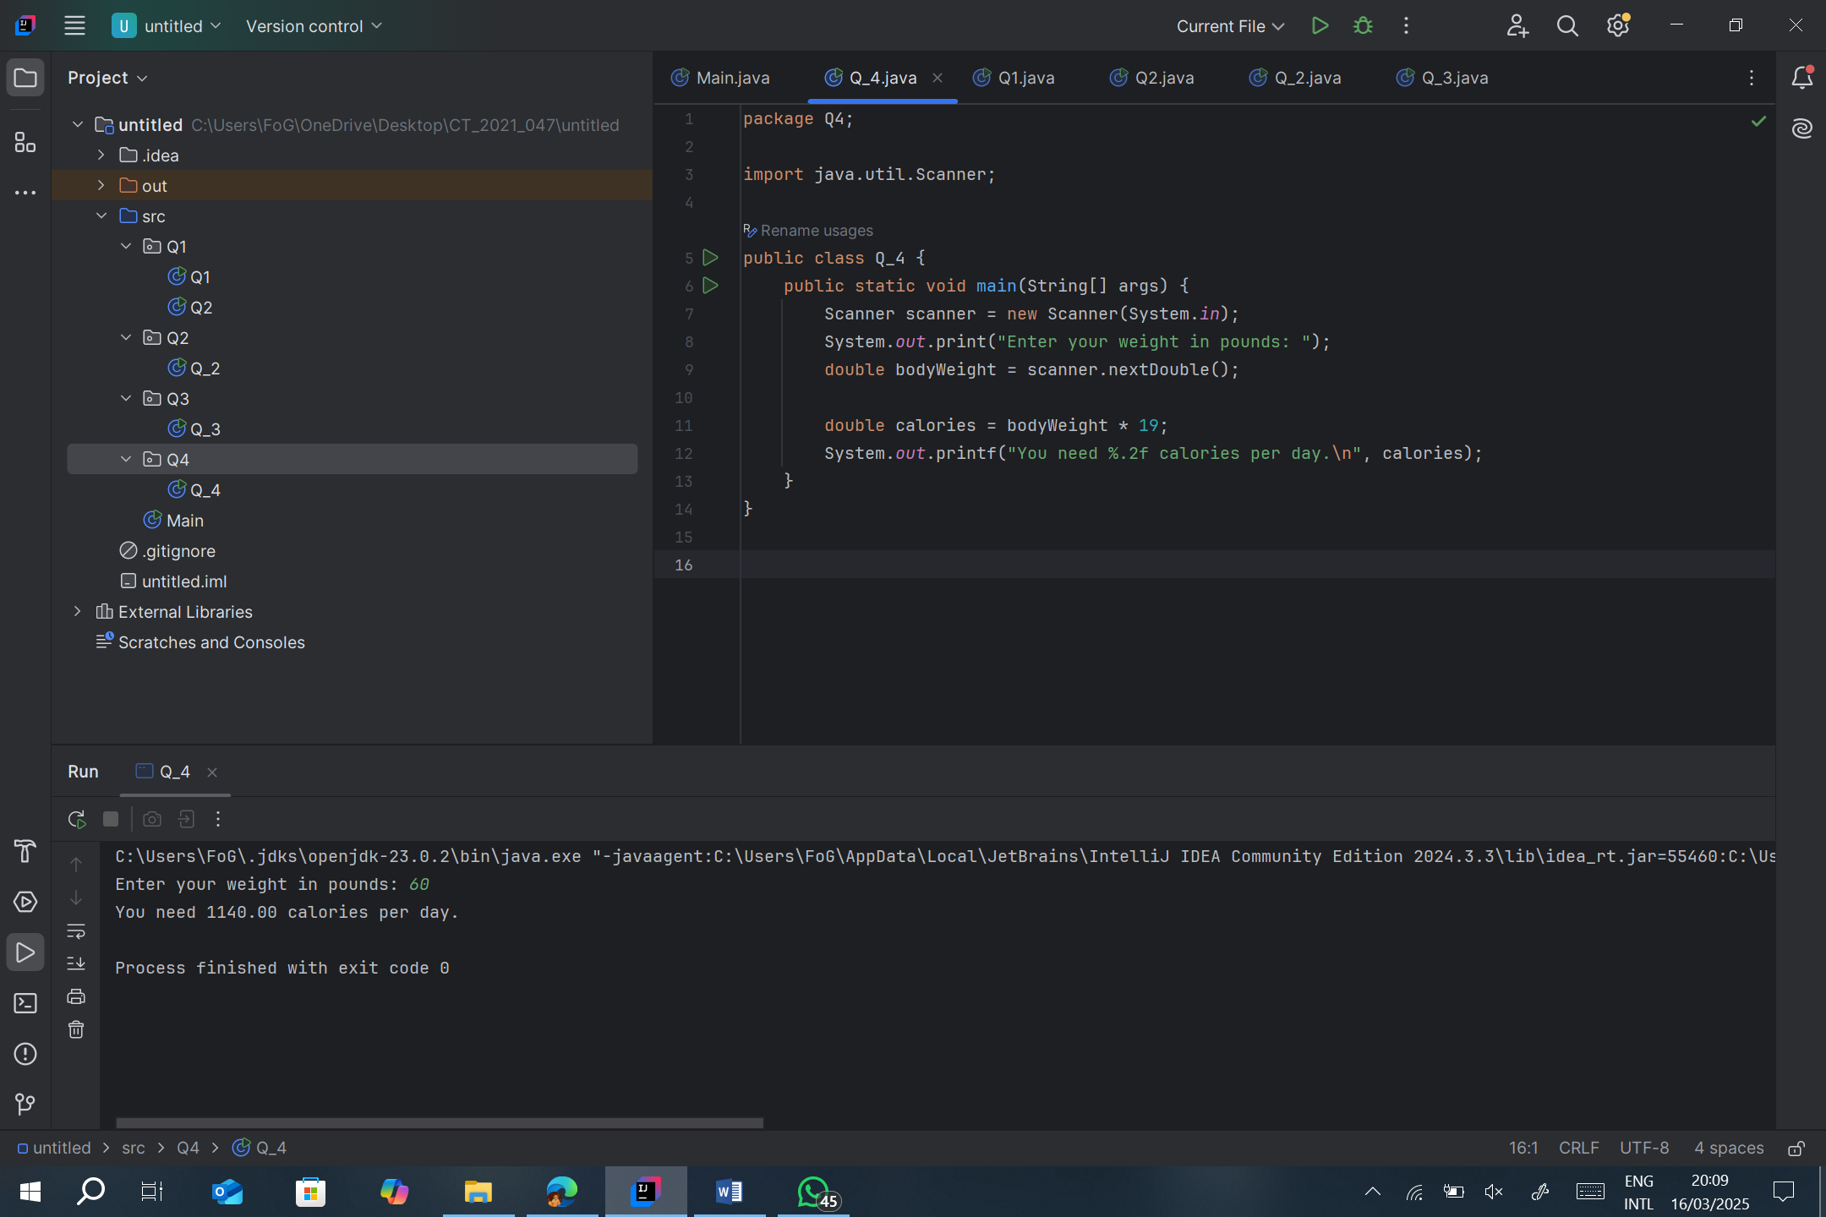

Q5.

package Q5;  
  
import java.util.Scanner;  
  
public class Q_5 {  
 public static void main(String[] args) {  
 Scanner scanner = new Scanner(System.*in*);  
 System.*out*.print("Enter temperature in Fahrenheit: ");  
 double fahrenheit = scanner.nextDouble();  
  
 double celsius = (fahrenheit - 32) / 1.8;  
 System.*out*.printf("Temperature in Celsius: %.2f\n", celsius);  
 }  
}

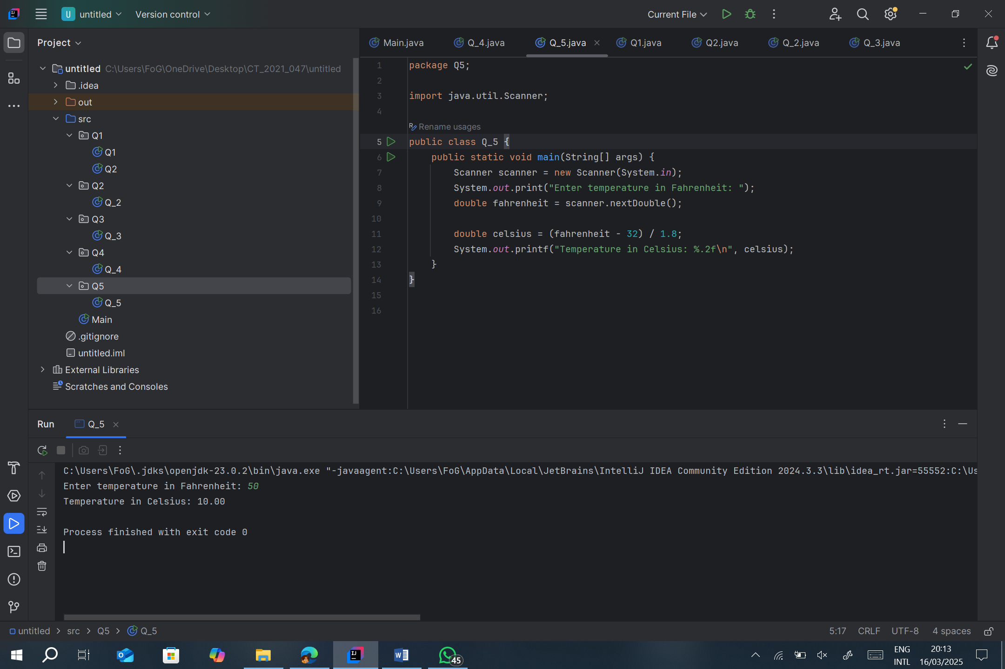

Q6.

package Q6;  
  
import java.util.Scanner;  
  
public class Q_6 {  
 public static void main(String[] args) {  
 Scanner scanner = new Scanner(System.*in*);  
  
 System.*out*.print("Enter your year of birth: ");  
 int birthYear = scanner.nextInt();  
  
 int currentYear = java.time.Year.*now*().getValue();  
 int age = currentYear - birthYear;  
  
 System.*out*.printf("You were born in %d and are %d years old this year.\n", birthYear, age);  
 }  
}

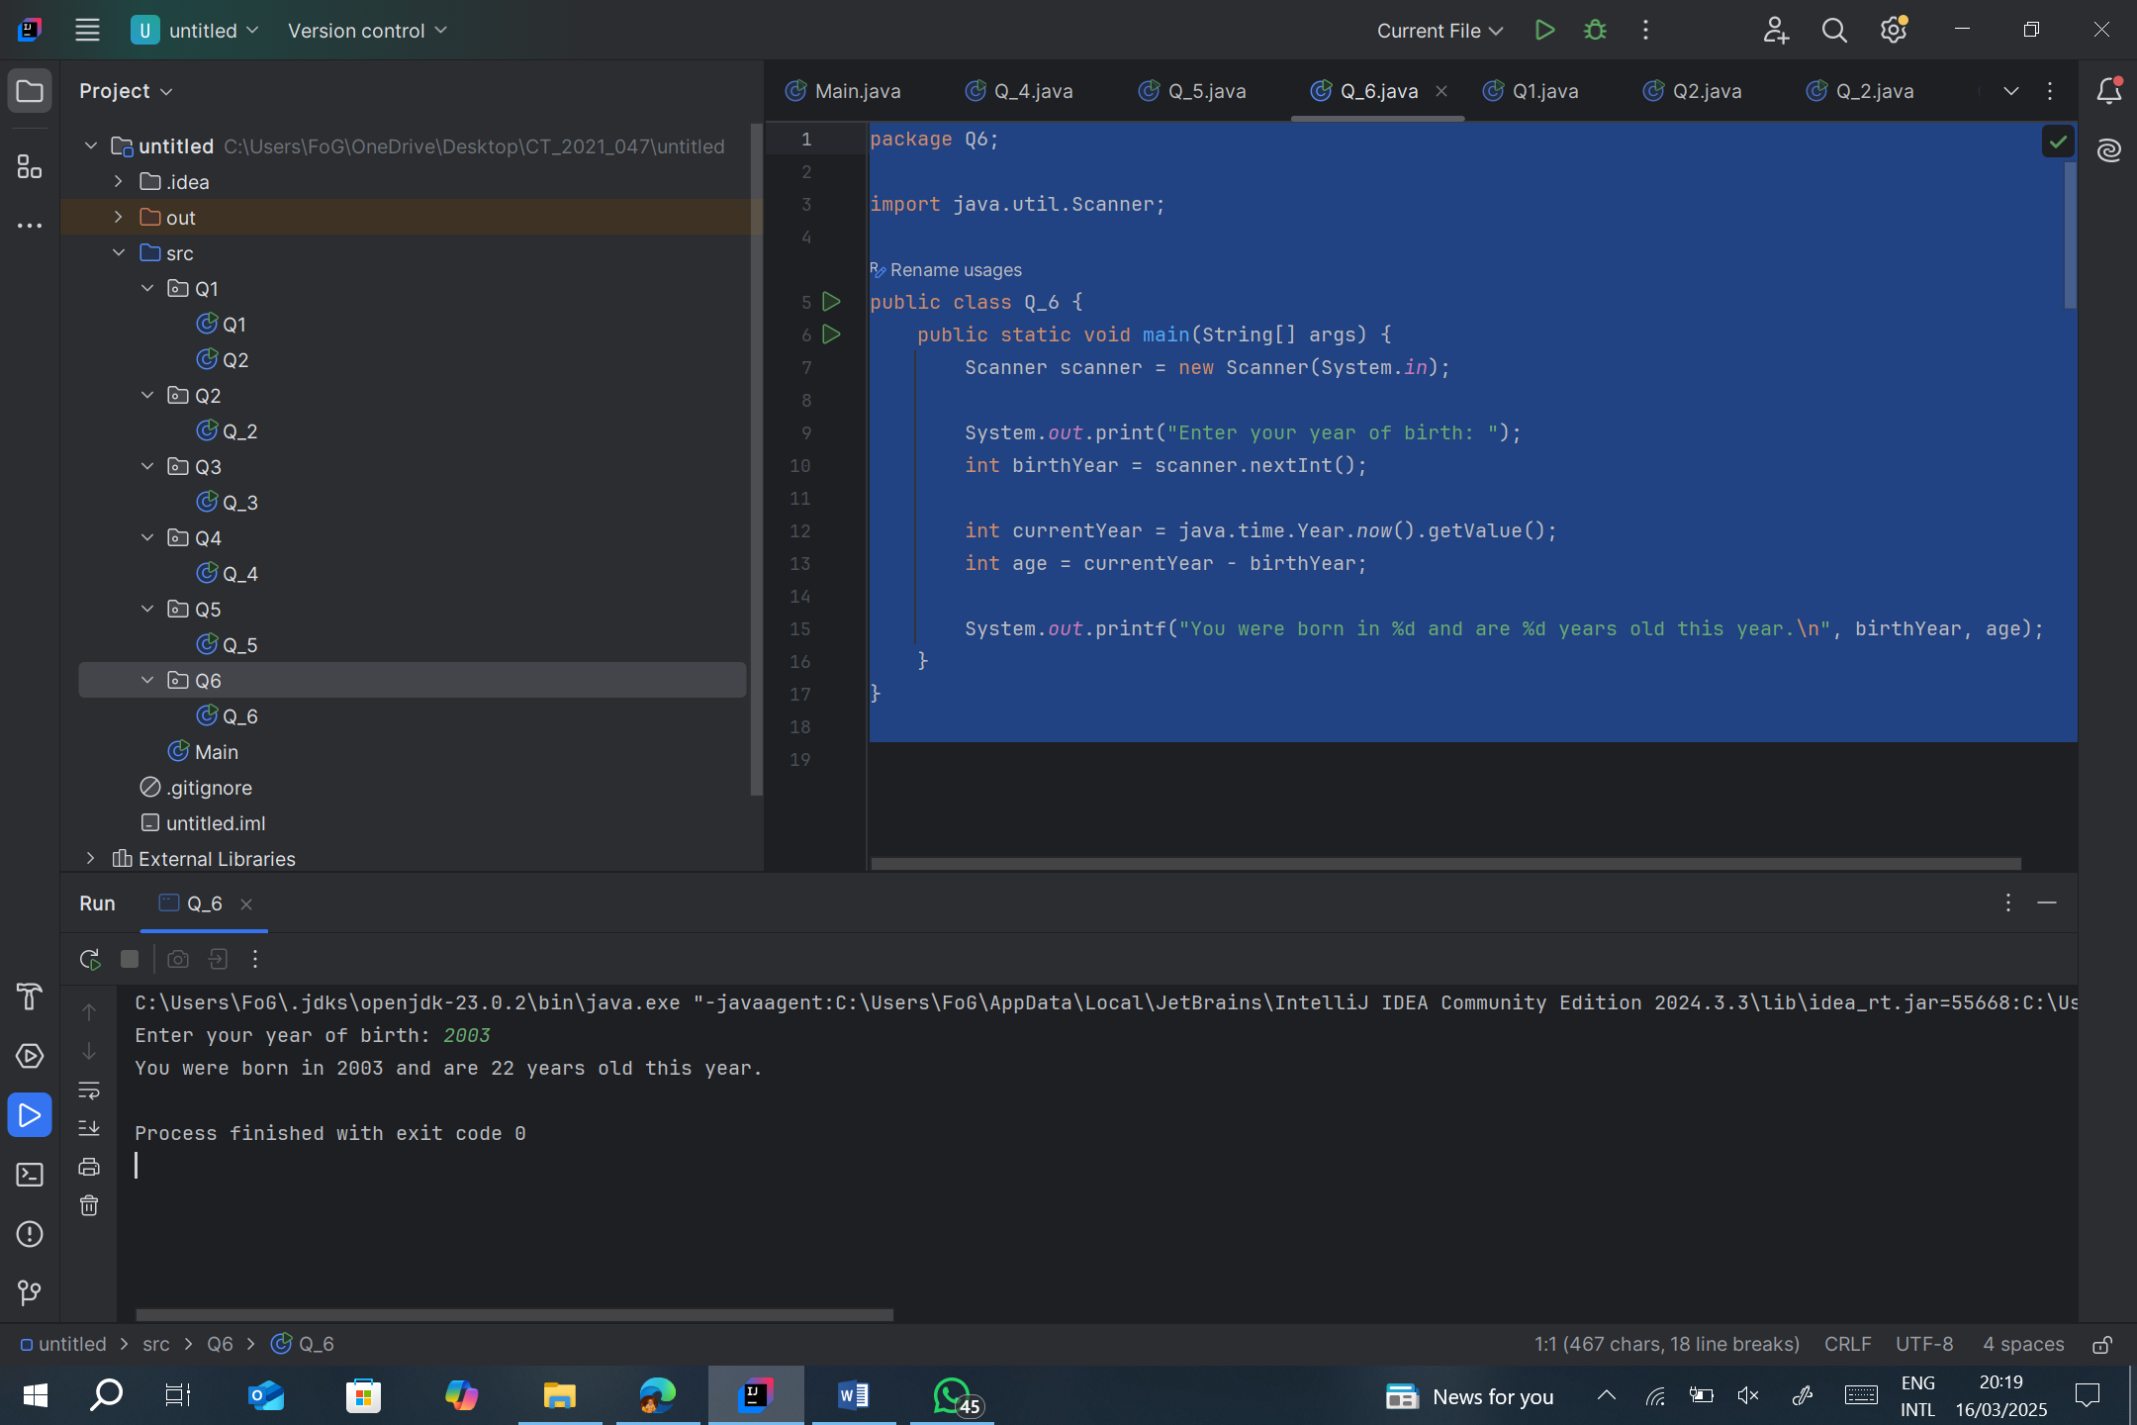

Q7

package Q7;  
  
import java.util.Scanner;  
  
public class Q_7{  
 public static void main(String[] args) {  
 Scanner scanner = new Scanner(System.*in*);  
  
 System.*out*.print("Enter weight in kilograms: ");  
 double weight = scanner.nextDouble();  
  
 System.*out*.print("Enter height in centimeters: ");  
 double height = scanner.nextDouble();  
  
 double bmi = weight / Math.*pow*(height / 100, 2);  
 System.*out*.printf("Your BMI is: %.2f\n", bmi);  
 }  
}

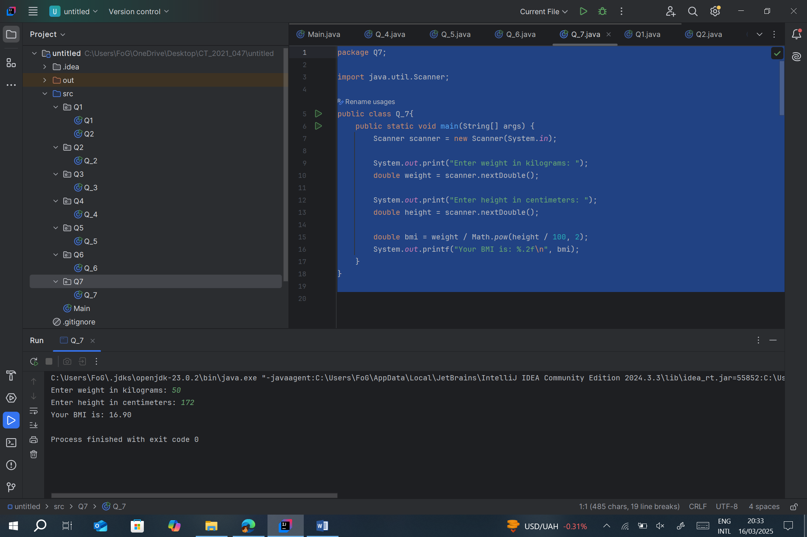

Q8

package Q8;  
  
import java.util.Scanner;  
  
public class Q_8 {  
 public static void main(String[] args) {  
 Scanner scanner = new Scanner(System.*in*);  
  
 System.*out*.print("Enter radius of the sphere: ");  
 double radius = scanner.nextDouble();  
  
 double volume = (4.0 / 3.0) * Math.*PI* * Math.*pow*(radius, 3);  
 System.*out*.printf("The volume of the sphere is: %.2f\n", volume);  
 }  
}

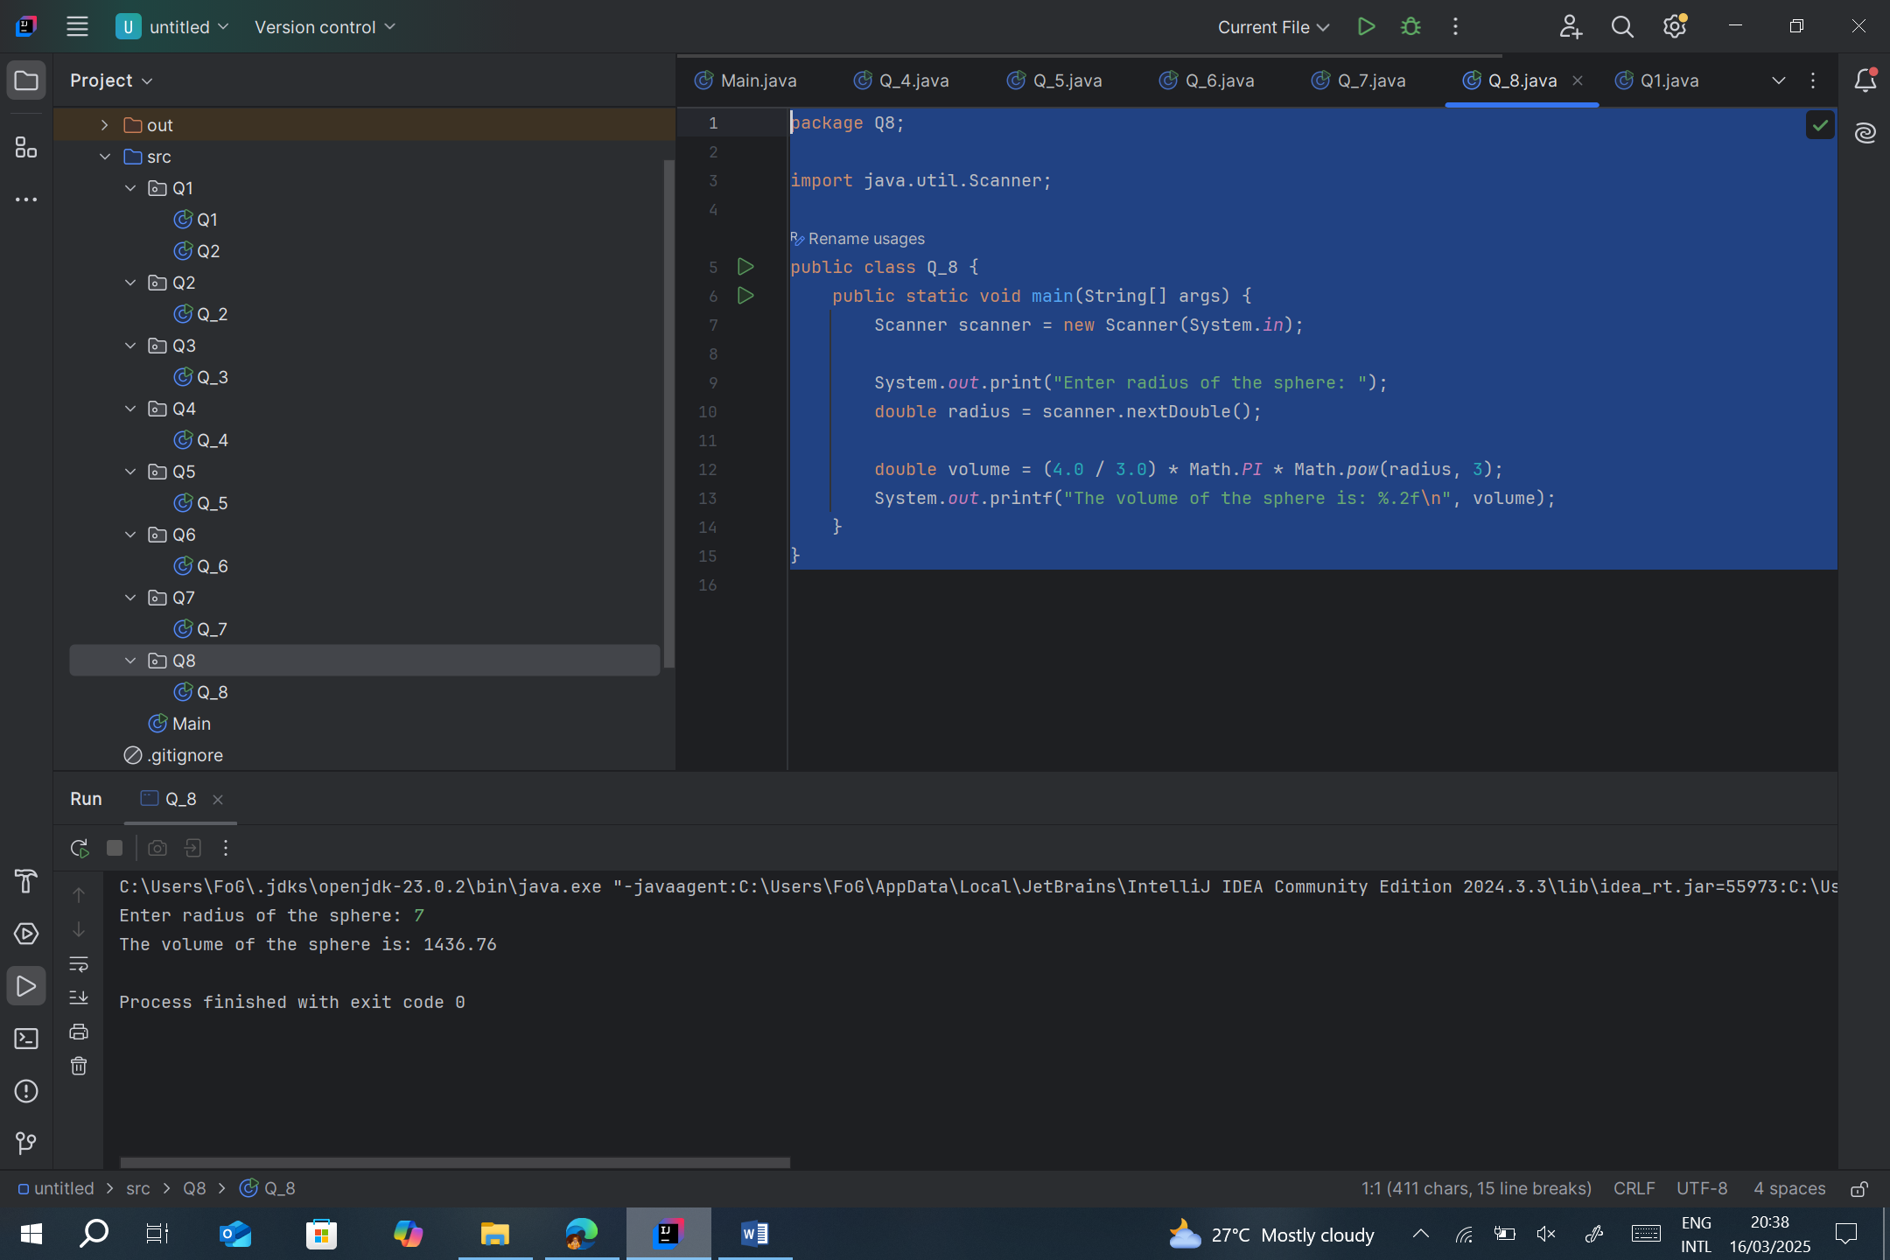

Q9

package Q9;  
  
import java.util.Scanner;  
  
public class Q_9 {  
 public static void main(String[] args) {  
 Scanner scanner = new Scanner(System.*in*);  
  
 System.*out*.print("Enter principal amount: ");  
 double principal = scanner.nextDouble();  
  
 System.*out*.print("Enter annual interest rate (in percentage): ");  
 double rate = scanner.nextDouble();  
  
 System.*out*.print("Enter number of years: ");  
 int years = scanner.nextInt();  
  
 double amount = principal * Math.*pow*(1 + (rate / 100), years);  
 System.*out*.printf("The investment will grow to: %.2f\n", amount);  
 }  
}

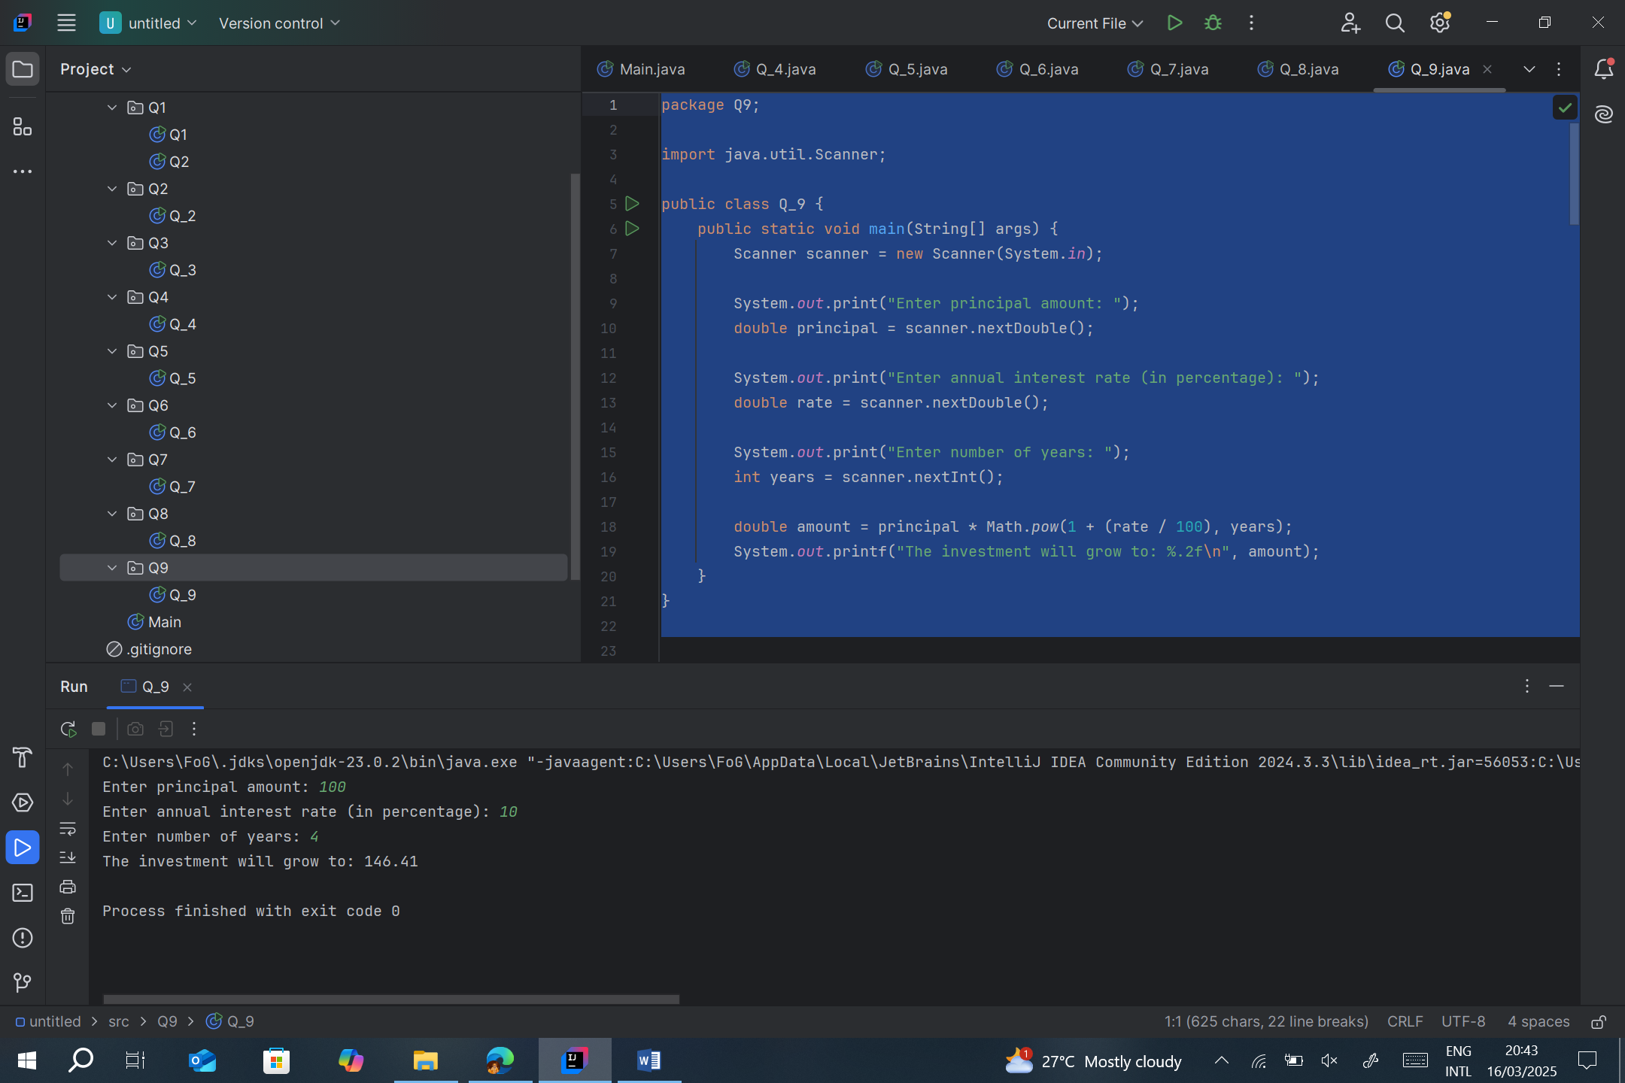

Q10

package Q10;  
  
import java.util.Scanner;  
  
public class Q_10 {  
 public static void main(String[] args) {  
 Scanner scanner = new Scanner(System.*in*);  
  
 System.*out*.print("Enter loan amount: ");  
 double loanAmount = scanner.nextDouble();  
  
 System.*out*.print("Enter annual interest rate (in percentage): ");  
 double annualInterestRate = scanner.nextDouble();  
  
 System.*out*.print("Enter loan period (in years): ");  
 int loanPeriod = scanner.nextInt();  
  
 final int MONTHS_IN_YEAR = 12;  
 double monthlyInterestRate = annualInterestRate / 100.0 / MONTHS_IN_YEAR;  
 int numberOfPayments = loanPeriod * MONTHS_IN_YEAR;  
  
 double monthlyPayment = (loanAmount * monthlyInterestRate) /  
 (1 - Math.*pow*(1 / (1 + monthlyInterestRate), numberOfPayments));  
 double totalPayment = monthlyPayment * numberOfPayments;  
  
 System.*out*.printf("Monthly Payment: %.2f\n", monthlyPayment);  
 System.*out*.printf("Total Payment: %.2f\n", totalPayment);  
 }  
}

